Sprint 6 Report

**Team Members:** Austin Wentz and Jordan Doell

**Date:** April 12, 2013

**Class:**  Senior Design

**Subject:** Sprint 6 Report

**Sponsor:** L-3: June Alexander-Knight

# Backlog

## Completed

* Some Testing
* Presequenced the songs and made midi files with Vixen
* Finished integrating lights into XBMC
* Created display for Design Fair

## Remaining

* Testing

# Christmas Light Controller Progress

Austin Wentz

During sprint 6 I finished integrating the light sequencing into XBMC. Sequences and their associated songs can now be played within XBMC. Since we are using Vixen to create the sequences, I wrote a utility program that converts the sequence from Vixen’s format into our own format used within our plugin for XBMC.

# iPhone App Progress

Jordan Doell

I changed up the UI for the app in between sprints 5 and 6. Also, it sends out commands to the server now. This uses the JSON data format. The storyboard is shown in figure 1.

Most of the other time spent during this spring was for some testing and preparation for the design fair. This included figuring out what to do for the poster and designing it. The poster is almost complete. There are a few changes that need to be made but that shouldn’t take too long. Also, we are still figuring out how we want the design to look at the fair, like where the lights should go and how to organize our booth.

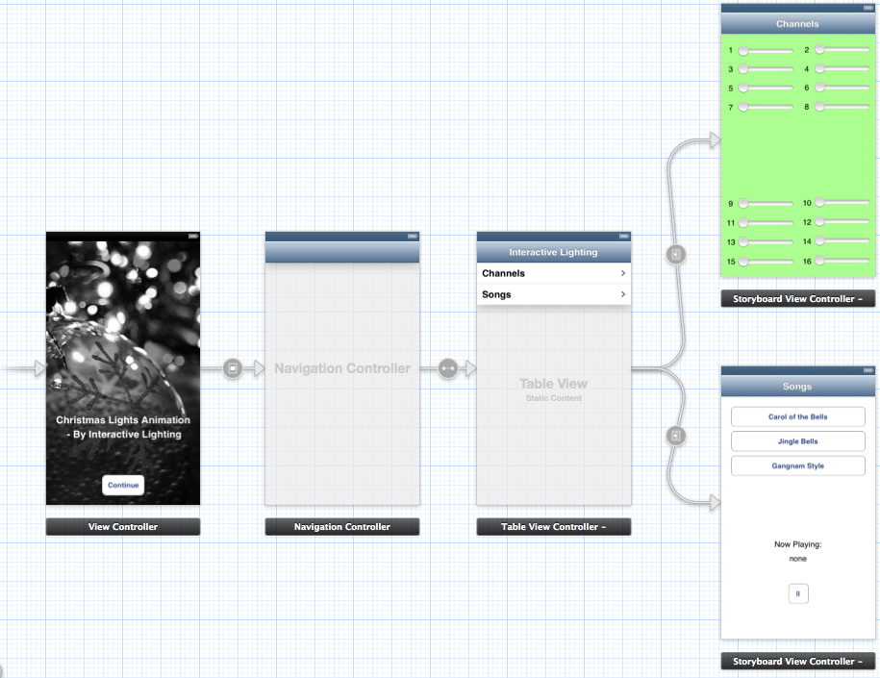

Figure 1: